Orange Dot 6.0 - Locality Profiles

Table of Contents

## Albemarle County

There are 27,331 families living in Albemarle County. Of these families, 5,010 (19%) do not earn enough to provide for their family’s basic needs.

Albemarle County at a glance:

The Self-Sufficiency Standard for an average family in Albemarle County is an annual income of $63,321.53. This is the income working families need to meet their basic necessities. These include: housing, child care, food, transportation, health care, miscellaneous expenses (clothing, telephone, household items), and taxes (minus federal and state tax credits).

Approximately 5,010 families, or 19% of families, in Albemarle County earn below the Self-Sufficiency Standard.

The percent of Black families earning below the Self-Sufficiency Standard is 46%. The percent of Hispanic families earning below the Self-Sufficiency Standard is 30%. These are 31% and 15% higher than the percent of white families earning below the Self-Sufficiency Standard (15%).

The median family income for Albemarle County is $126,769. The tract with the lowest median family income is Oak Hill, Southwood at $60,700. The tract with the highest median family income is Ivy at $216,300.

The tract with the highest percent of families with income below the Self-Sufficiency Standard is Hydraulic and Oak Hill, Southwood with 49% of families. The tract with the lowest percent of families earning below the Self-Sufficiency Standard is Hollymead with 4% of families. That is a difference of 45%.

Table 1: Average Expenses and Self-Sufficiency Wages for Families in Albemarle County

|  | Monthly | Annual |
| --- | --- | --- |
| Housing Costs | $1,261.29 | $15,135.48 |
| Child Care Costs | $1,041.73 | $12,500.76 |
| Food Costs | $719.86 | $8,638.32 |
| Transportation Costs | $413.34 | $4,960.08 |
| Health Care Costs | $723.81 | $8,685.72 |
| Miscellaneous Costs | $416.00 | $4,992.00 |
| Taxes | $1,038.95 | $12,467.40 |
| Earned Income Tax Credit | -$1.52 | -$18.24 |
| Child Care Tax Credit | -$70.00 | -$840.00 |
| Child Tax Credit | -$266.67 | -$3,200.04 |
| **Self Sufficiency Wage** | **$5,276.79** | **$63,321.53** |
| Data Source: The Self-Sufficiency Standard for Virginia, 2021; The Center for Women’s Welfare, University of Washington | | |

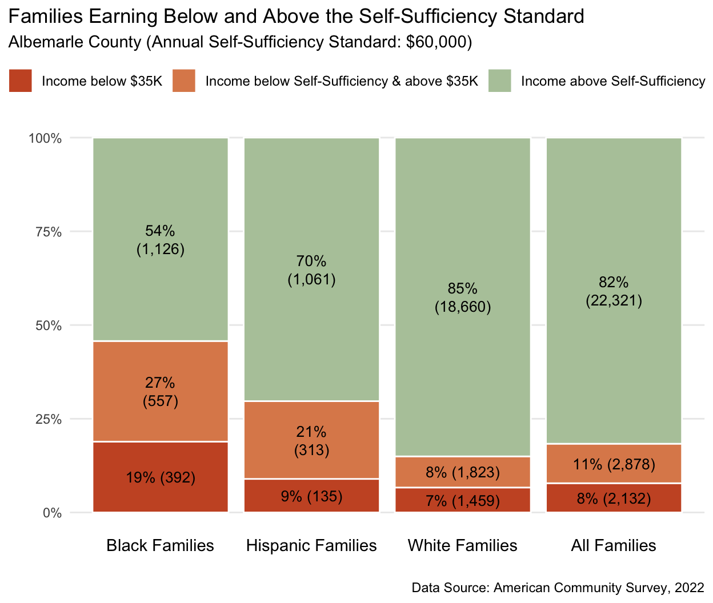

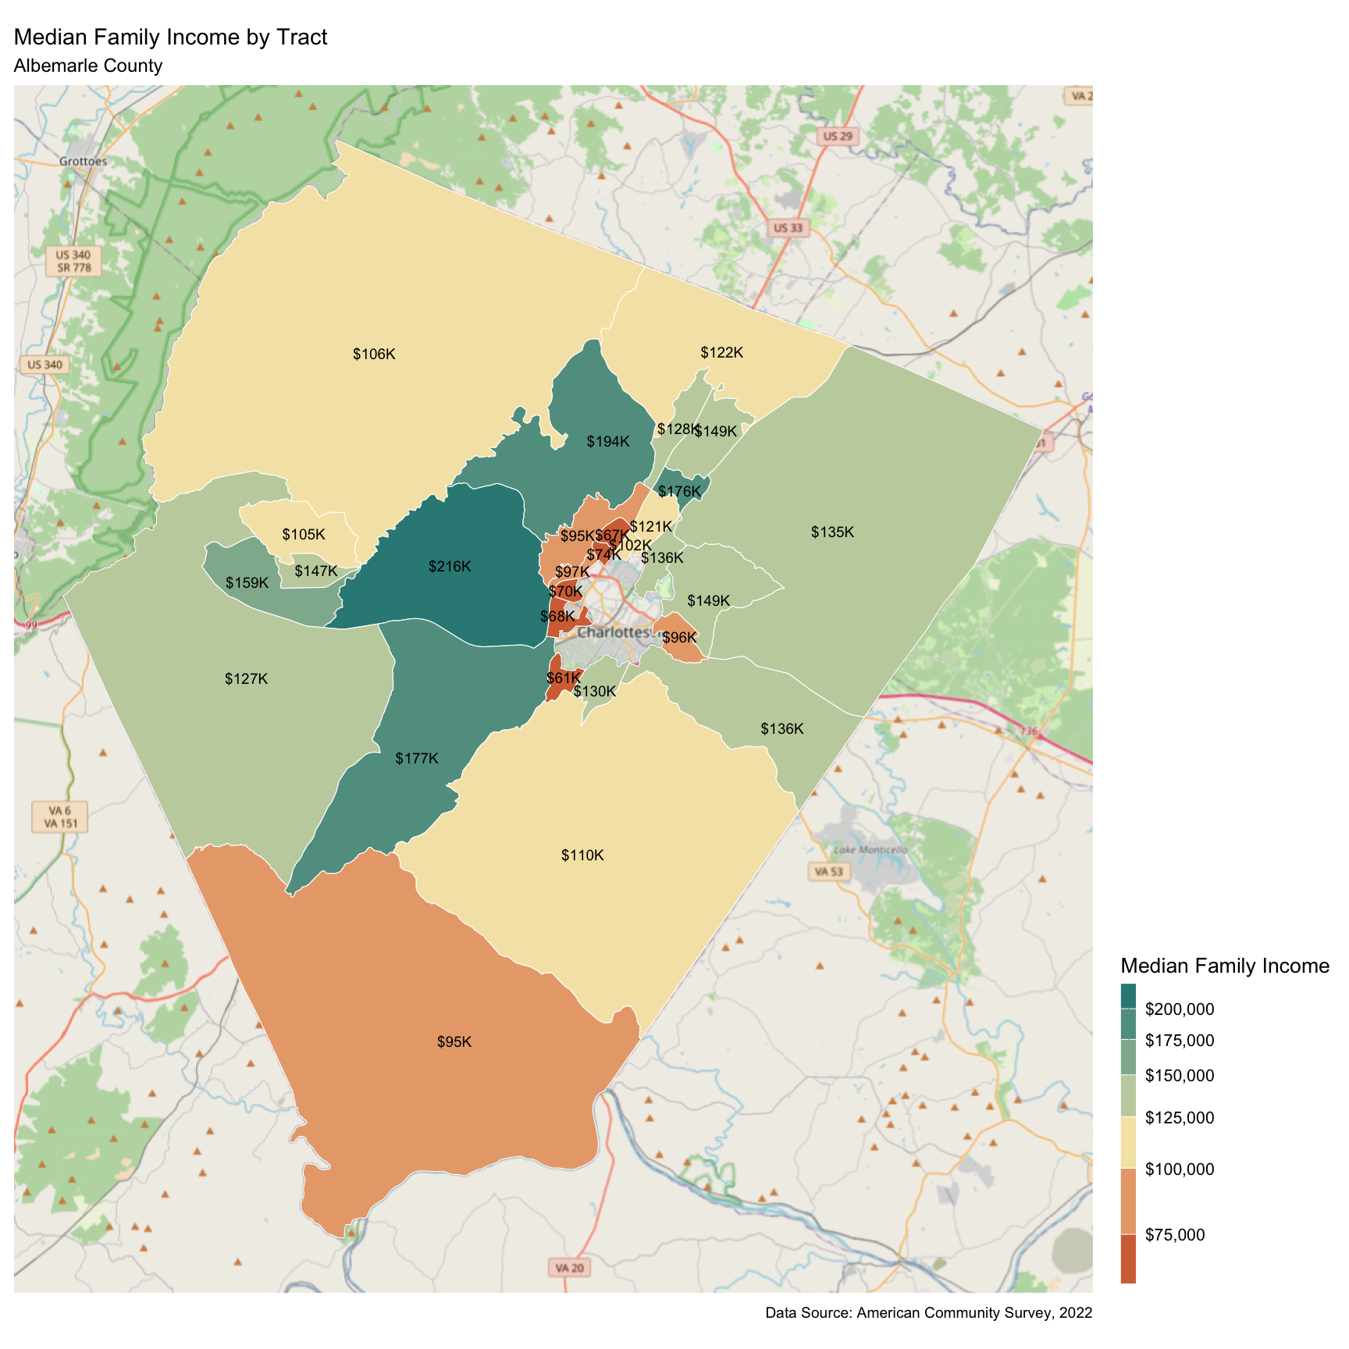

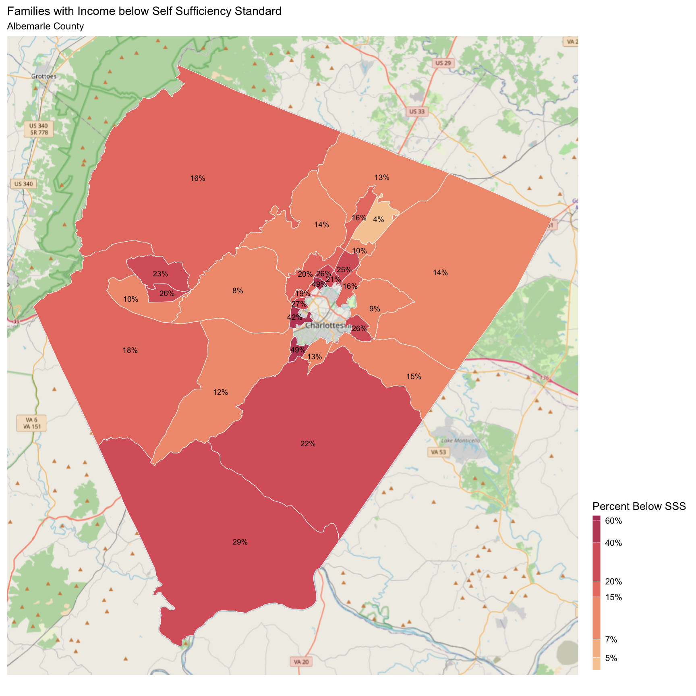

## Buckingham County

There are 3,975 families living in Buckingham County. Of these families, 1,028 (25%) do not earn enough to provide for their family’s basic needs.

Buckingham County at a glance:

The Self-Sufficiency Standard for an average family in Buckingham County is an annual income of $44,475.07. This is the income working families need to meet their basic necessities. These include: housing, child care, food, transportation, health care, miscellaneous expenses (clothing, telephone, household items), and taxes (minus federal and state tax credits).

Approximately 1,028 families, or 25% of families, in Buckingham County earn below the Self-Sufficiency Standard.

The percent of Black families earning below the Self-Sufficiency Standard is 38%. This is 19% higher than the percent of white families earning below the Self-Sufficiency Standard (19%).

The median family income for Buckingham County is $76,351. The tract with the lowest median family income is James River at $66,500. The tract with the highest median family income is Mount Rush at $98,600.

The tract with the highest percent of families with income below the Self-Sufficiency Standard is James River with 34% of families. The tract with the lowest percent of families earning below the Self-Sufficiency Standard is Mount Rush with 16% of families. That is a difference of 18%.

Table 1: Average Expenses and Self-Sufficiency Wages for Families in Buckingham County

|  | Monthly | Annual |
| --- | --- | --- |
| Housing Costs | $736.93 | $8,843.16 |
| Child Care Costs | $590.85 | $7,090.20 |
| Food Costs | $696.64 | $8,359.68 |
| Transportation Costs | $416.34 | $4,996.08 |
| Health Care Costs | $725.25 | $8,703.00 |
| Miscellaneous Costs | $316.60 | $3,799.20 |
| Taxes | $625.79 | $7,509.48 |
| Earned Income Tax Credit | -$69.28 | -$831.36 |
| Child Care Tax Credit | -$69.79 | -$837.48 |
| Child Tax Credit | -$263.07 | -$3,156.84 |
| **Self Sufficiency Wage** | **$3,706.26** | **$44,475.07** |
| Data Source: The Self-Sufficiency Standard for Virginia, 2021; The Center for Women’s Welfare, University of Washington | | |

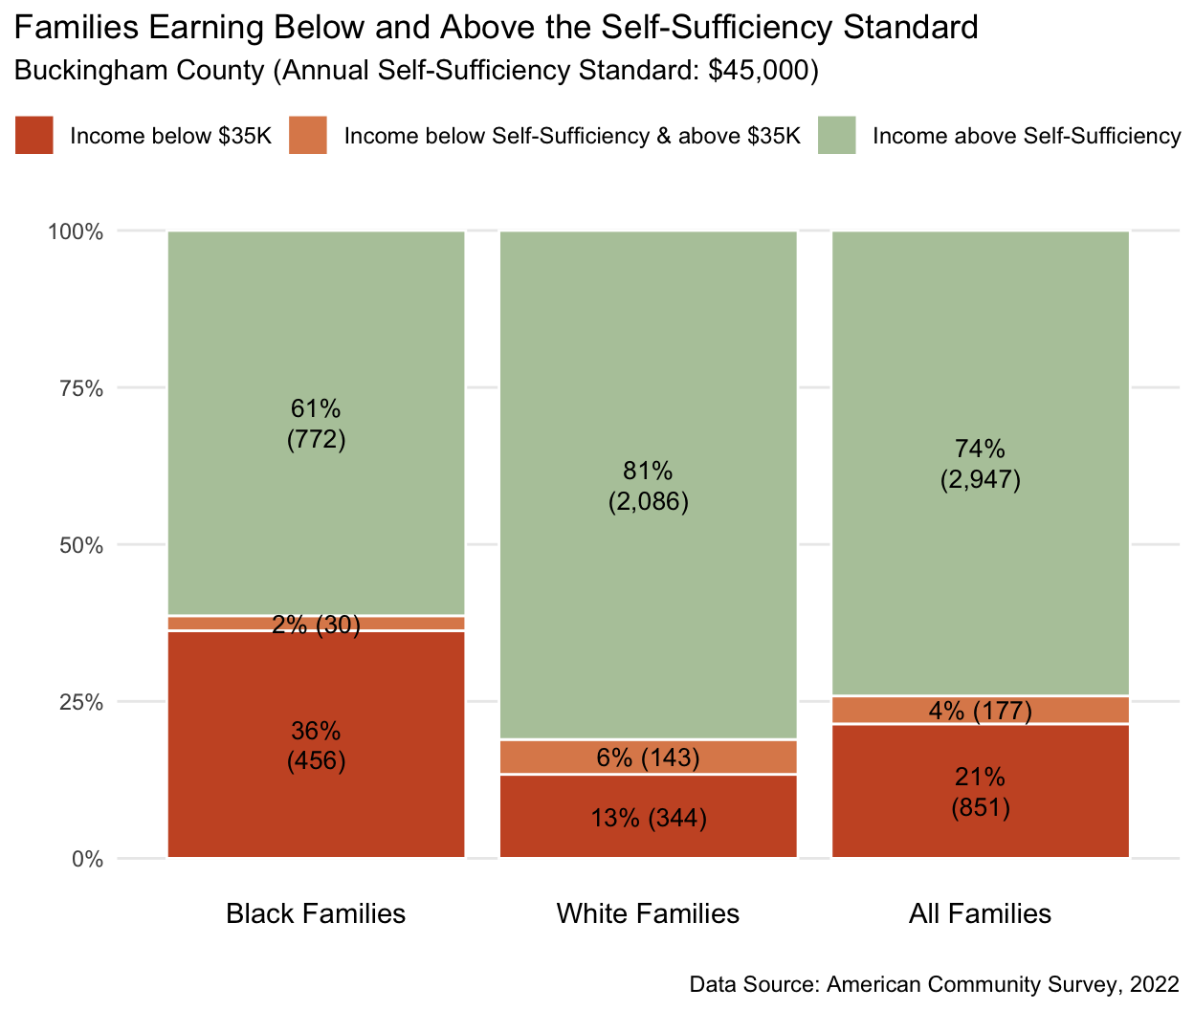

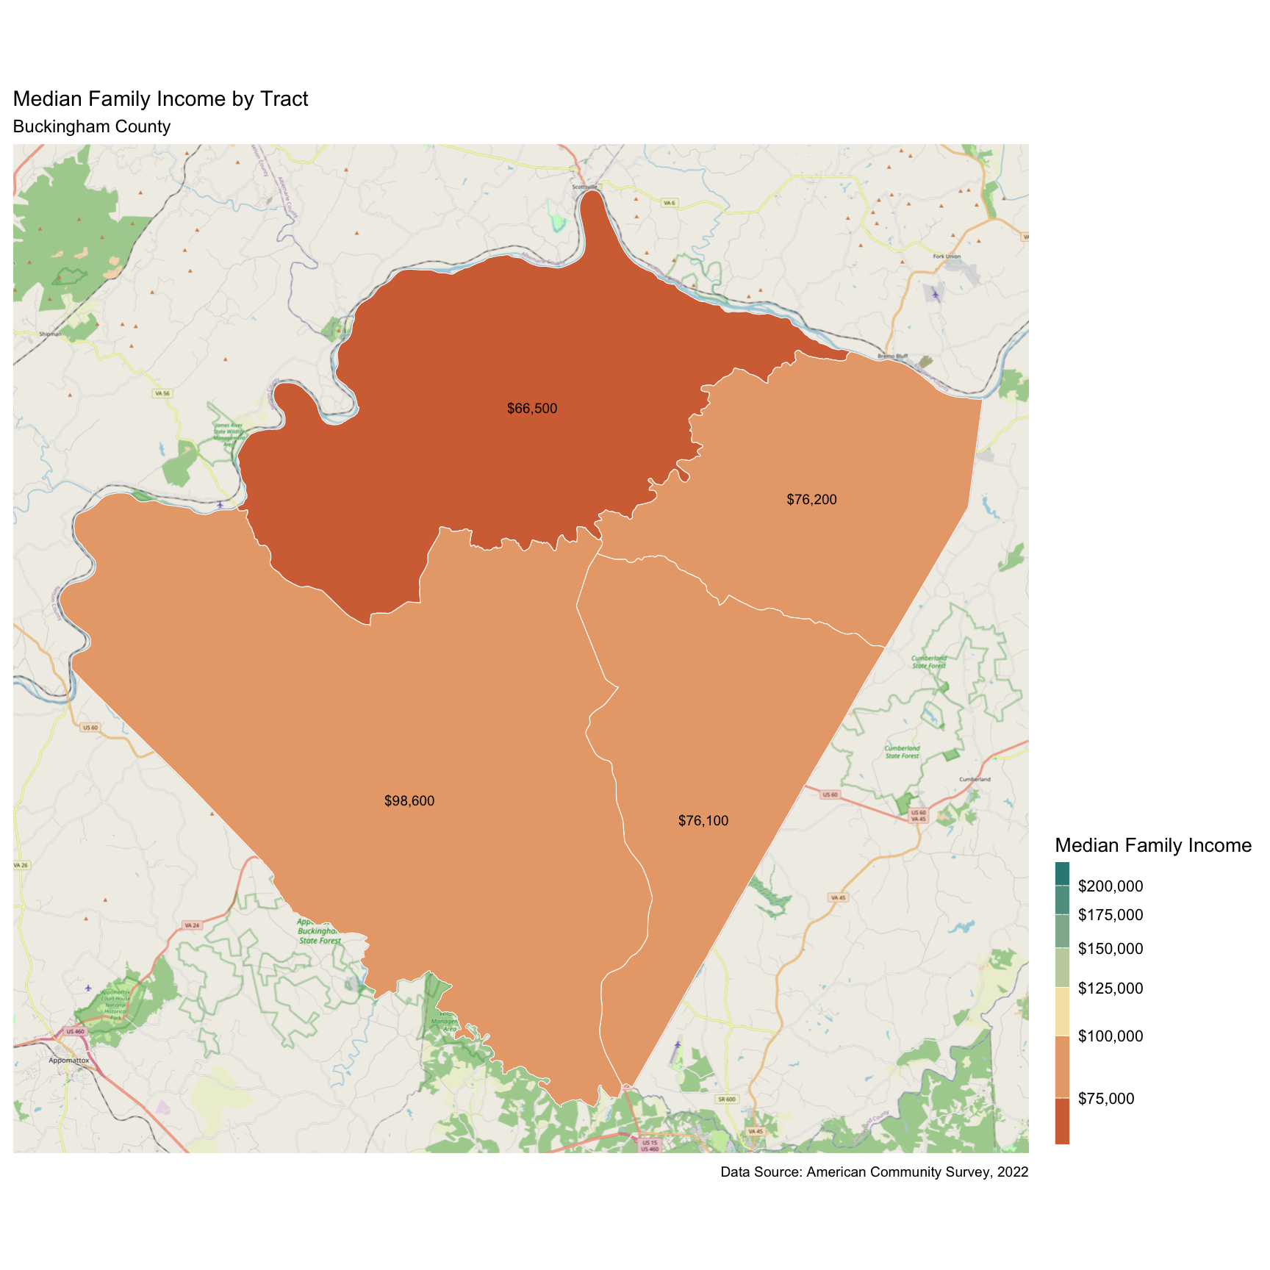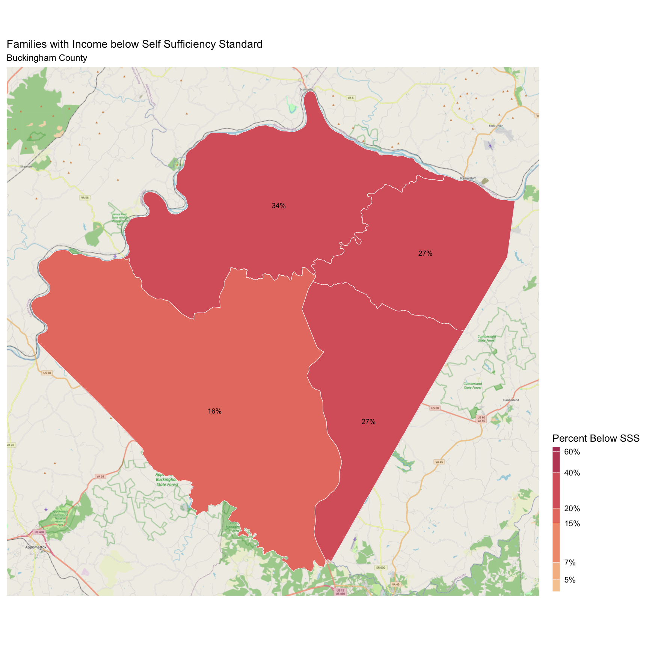

## City of Charlottesville

There are 8,805 families living in Charlottesville City. Of these families, 2,373 (27%) do not earn enough to provide for their family’s basic needs.

Charlottesville City at a glance:

The Self-Sufficiency Standard for an average family in Charlottesville City is an annual income of $60,876.27. This is the income working families need to meet their basic necessities. These include: housing, child care, food, transportation, health care, miscellaneous expenses (clothing, telephone, household items), and taxes (minus federal and state tax credits).

Approximately 2,373 families, or 27% of families, in Charlottesville City earn below the Self-Sufficiency Standard.

The percent of Black families earning below the Self-Sufficiency Standard is 61%. The percent of Hispanic families earning below the Self-Sufficiency Standard is 60%. These are 45% and 44% higher than the percent of white families earning below the Self-Sufficiency Standard (16%).

The median family income for Charlottesville City is $105,994. The tract with the lowest median family income is Fifeville-Cherry Avenue at $61,000. The tract with the highest median family income is Barracks-Rugby at $222,400.

The tract with the highest percent of families with income below the Self-Sufficiency Standard is 10th & Page-Venable with 65% of families. The tract with the lowest percent of families earning below the Self-Sufficiency Standard is Locust Grove with 4% of families. That is a difference of 61%.

Table 1: Average Expenses and Self-Sufficiency Wages for Families in Charlottesville City

|  | Monthly | Annual |
| --- | --- | --- |
| Housing Costs | $1,279.26 | $15,351.12 |
| Child Care Costs | $1,041.73 | $12,500.76 |
| Food Costs | $943.63 | $11,323.56 |
| Transportation Costs | $30.00 | $360.00 |
| Health Care Costs | $723.81 | $8,685.72 |
| Miscellaneous Costs | $401.84 | $4,822.08 |
| Taxes | $992.56 | $11,910.72 |
| Earned Income Tax Credit | -$3.14 | -$37.68 |
| Child Care Tax Credit | -$70.00 | -$840.00 |
| Child Tax Credit | -$266.67 | -$3,200.04 |
| **Self Sufficiency Wage** | **$5,073.02** | **$60,876.27** |
| Data Source: The Self-Sufficiency Standard for Virginia, 2021; The Center for Women’s Welfare, University of Washington | | |

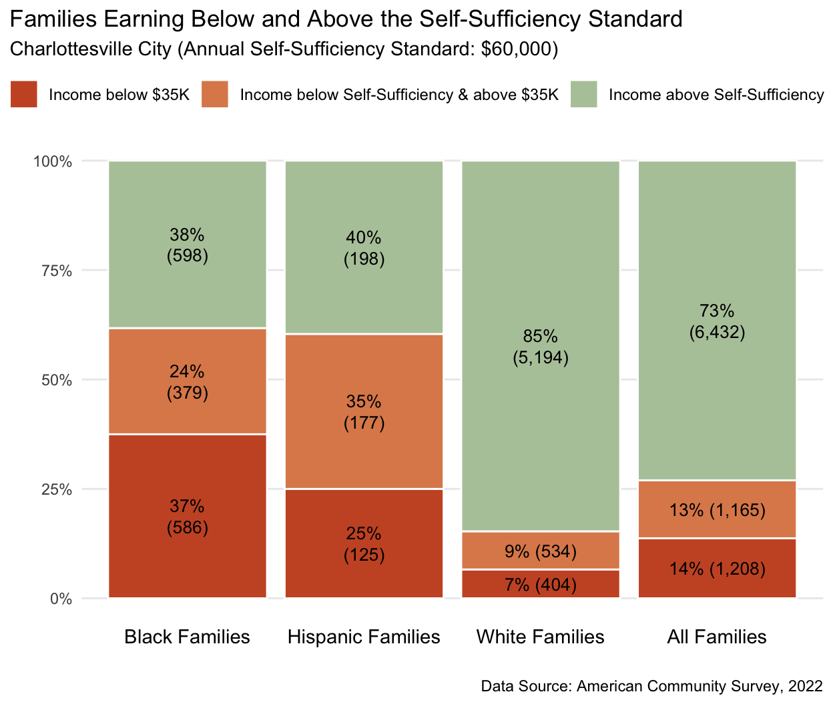

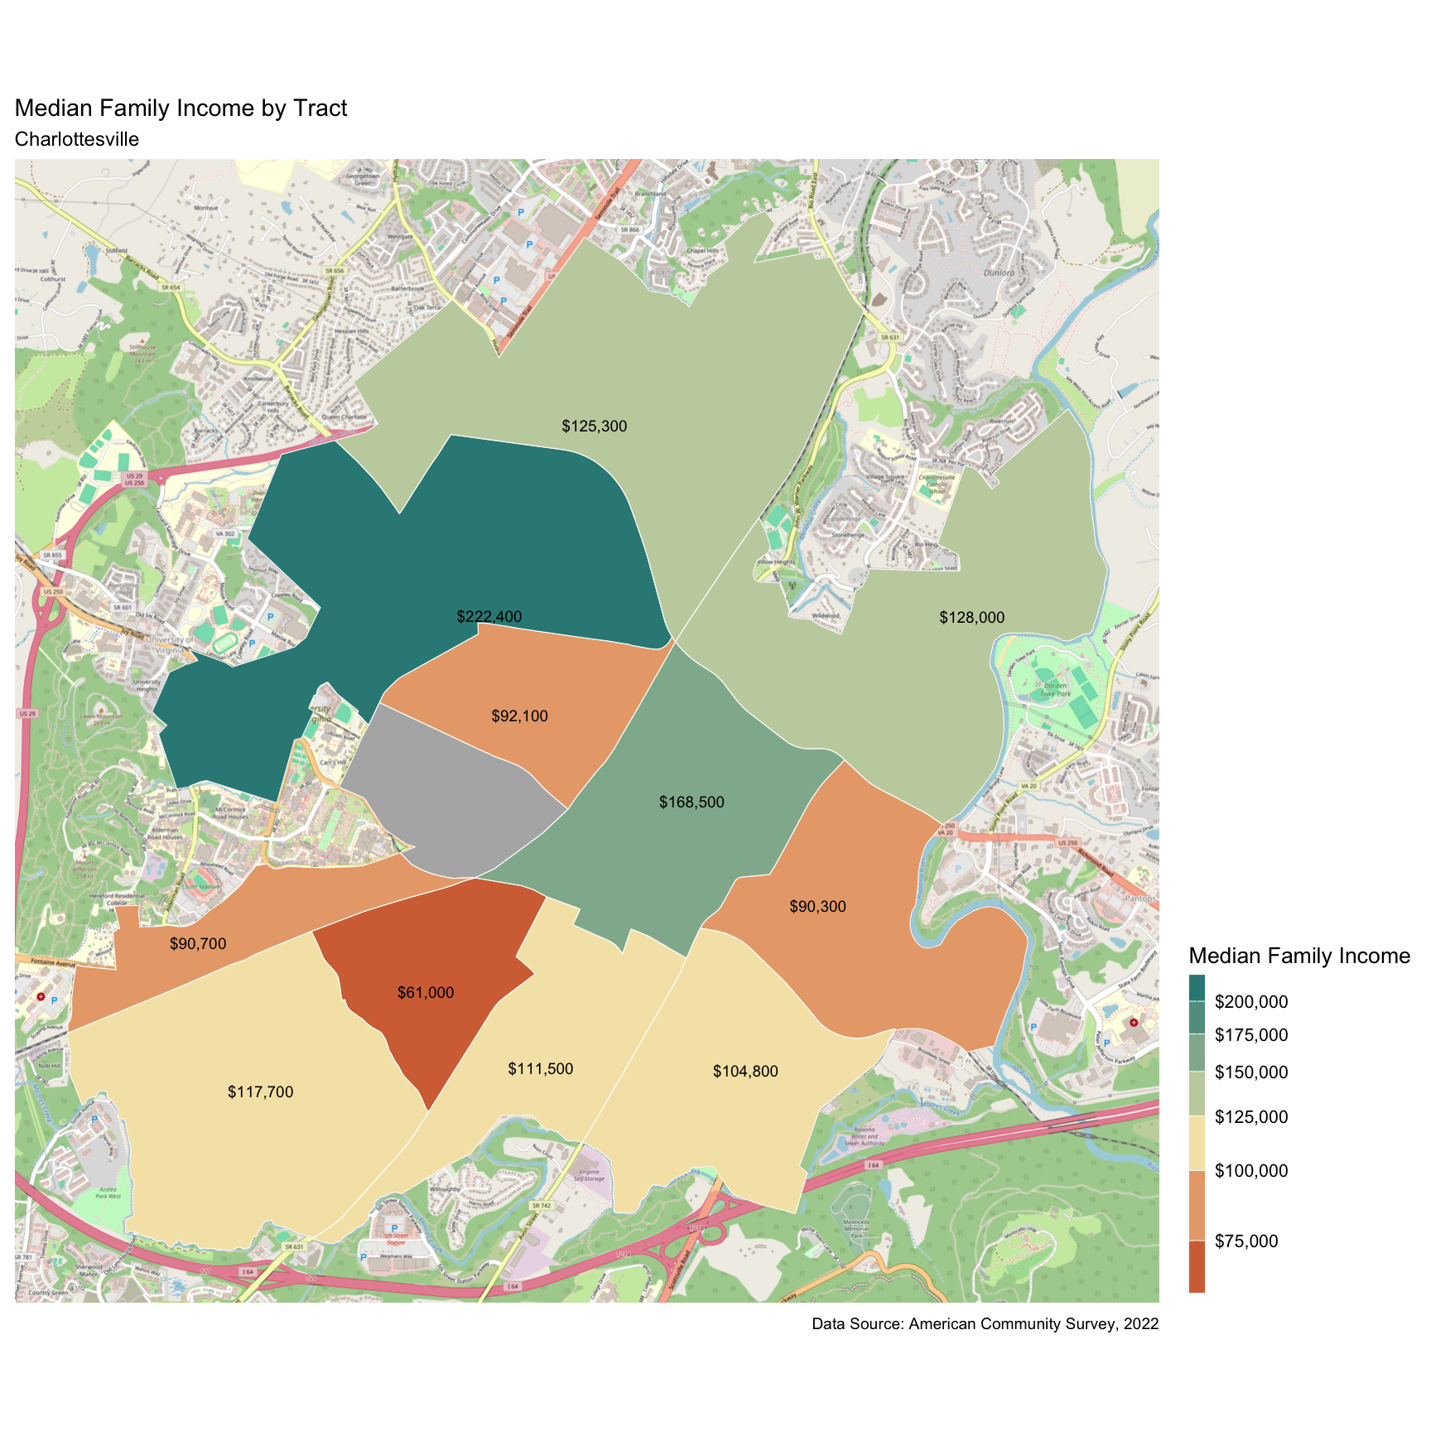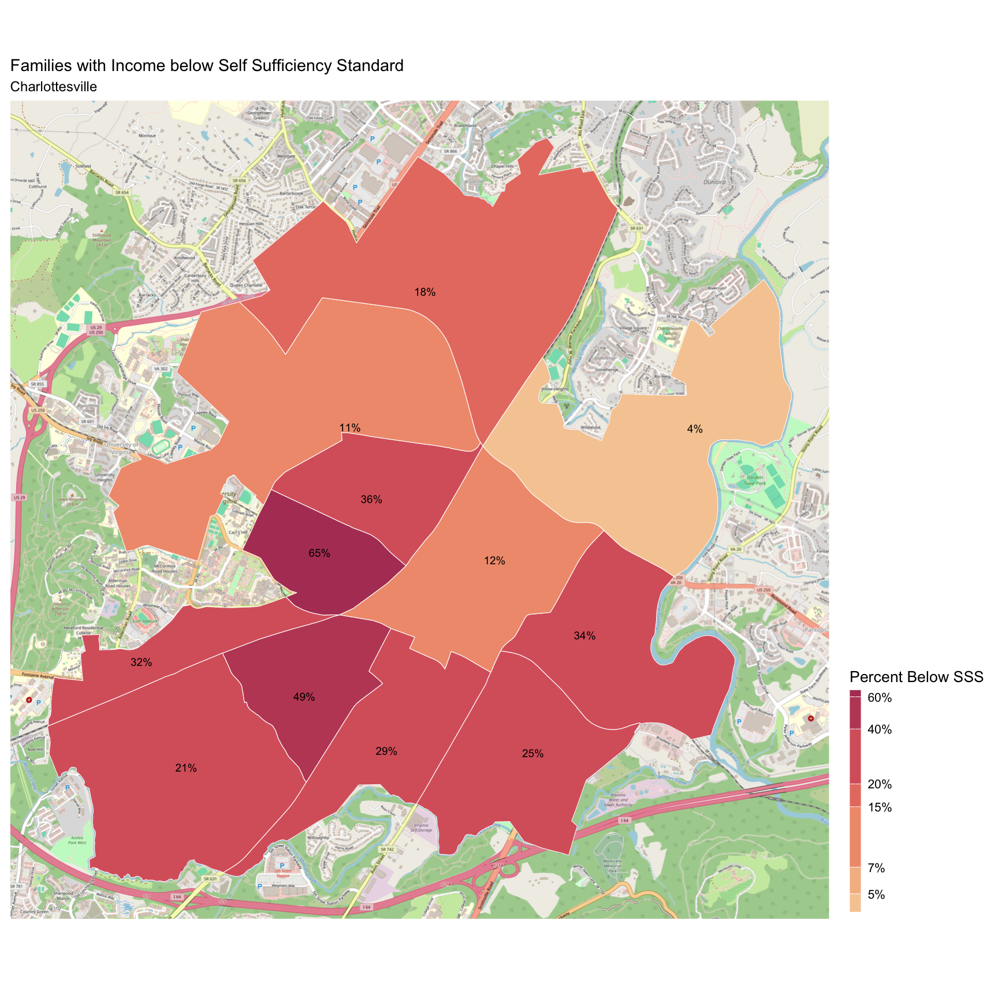

## Fluvanna County

There are 7,432 families living in Fluvanna County. Of these families, 1,579 (22%) do not earn enough to provide for their family’s basic needs.

Fluvanna County at a glance:

The Self-Sufficiency Standard for an average family in Fluvanna County is an annual income of $59,819.1. This is the income working families need to meet their basic necessities. These include: housing, child care, food, transportation, health care, miscellaneous expenses (clothing, telephone, household items), and taxes (minus federal and state tax credits).

Approximately 1,579 families, or 22% of families, in Fluvanna County earn below the Self-Sufficiency Standard.

The percent of Black families earning below the Self-Sufficiency Standard is 31%. This is 12% higher than the percent of white families earning below the Self-Sufficiency Standard (19%).

The median family income for Fluvanna County is $102,060. The tract with the lowest median family income is Columbia/Fork Union at $69,000. The tract with the highest median family income is Lake Monticello at $112,400.

The tract with the highest percent of families with income below the Self-Sufficiency Standard is Columbia/Fork Union with 37% of families. The tract with the lowest percent of families earning below the Self-Sufficiency Standard is Rivanna with 17% of families. That is a difference of 20%.

Table 1: Average Expenses and Self-Sufficiency Wages for Families in Fluvanna County

|  | Monthly | Annual |
| --- | --- | --- |
| Housing Costs | $1,333.76 | $16,005.12 |
| Child Care Costs | $726.94 | $8,723.28 |
| Food Costs | $759.97 | $9,119.64 |
| Transportation Costs | $416.34 | $4,996.08 |
| Health Care Costs | $723.81 | $8,685.72 |
| Miscellaneous Costs | $396.08 | $4,752.96 |
| Taxes | $963.75 | $11,565.00 |
| Earned Income Tax Credit | $0.00 | $0.00 |
| Child Care Tax Credit | -$69.06 | -$828.72 |
| Child Tax Credit | -$266.67 | -$3,200.04 |
| **Self Sufficiency Wage** | **$4,984.92** | **$59,819.10** |
| Data Source: The Self-Sufficiency Standard for Virginia, 2021; The Center for Women’s Welfare, University of Washington | | |

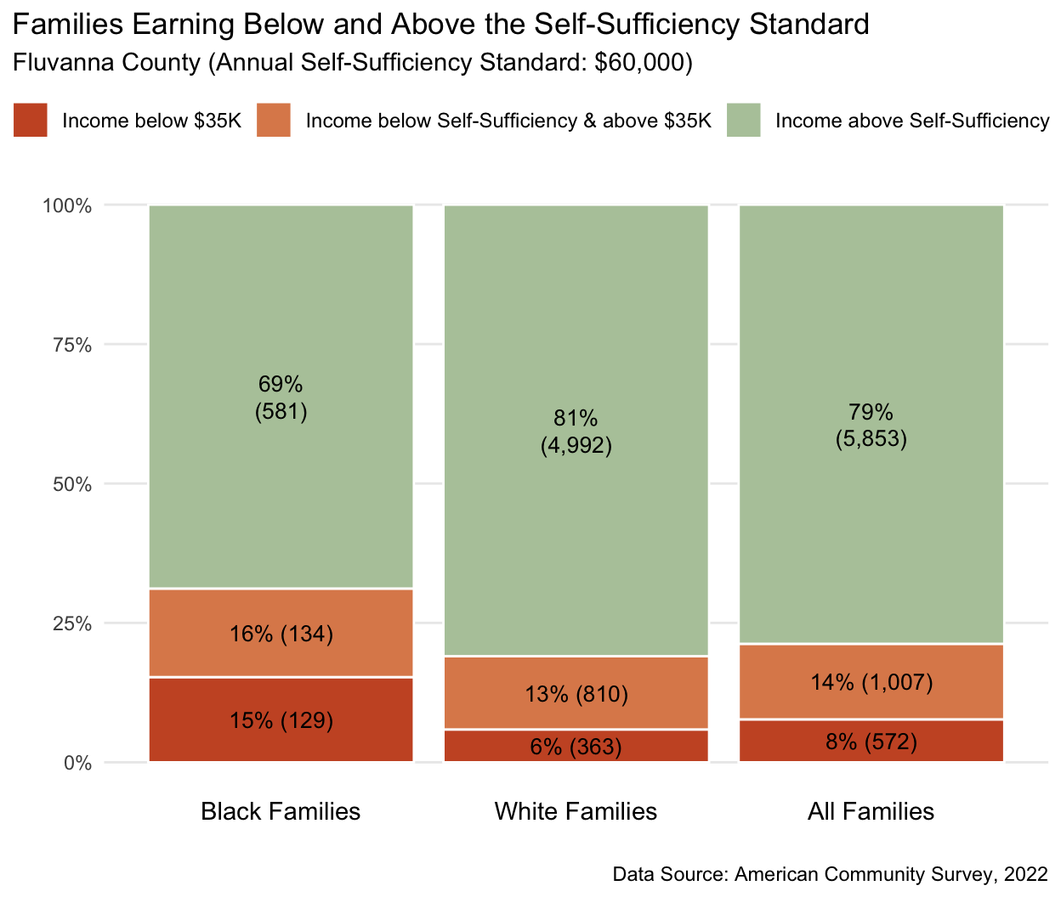

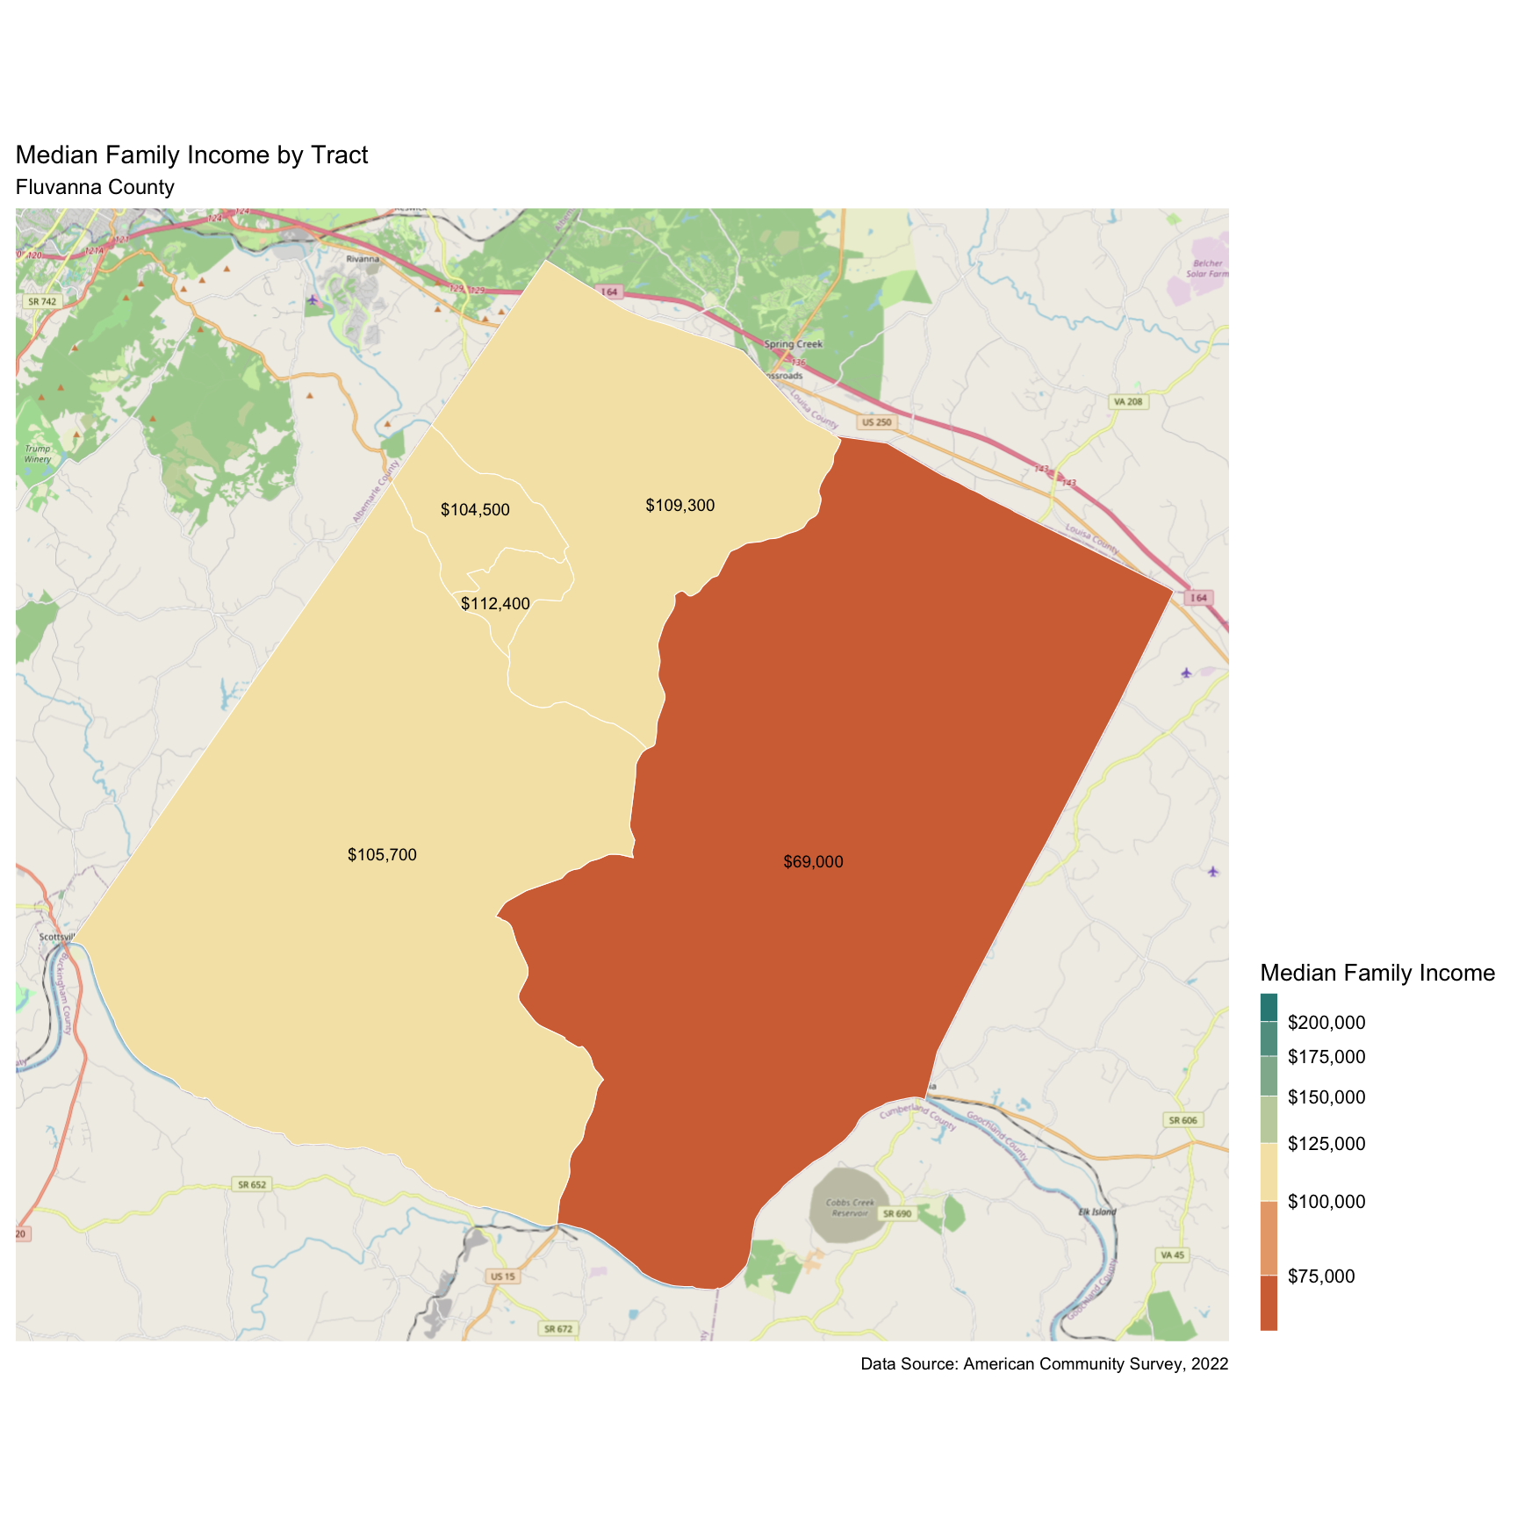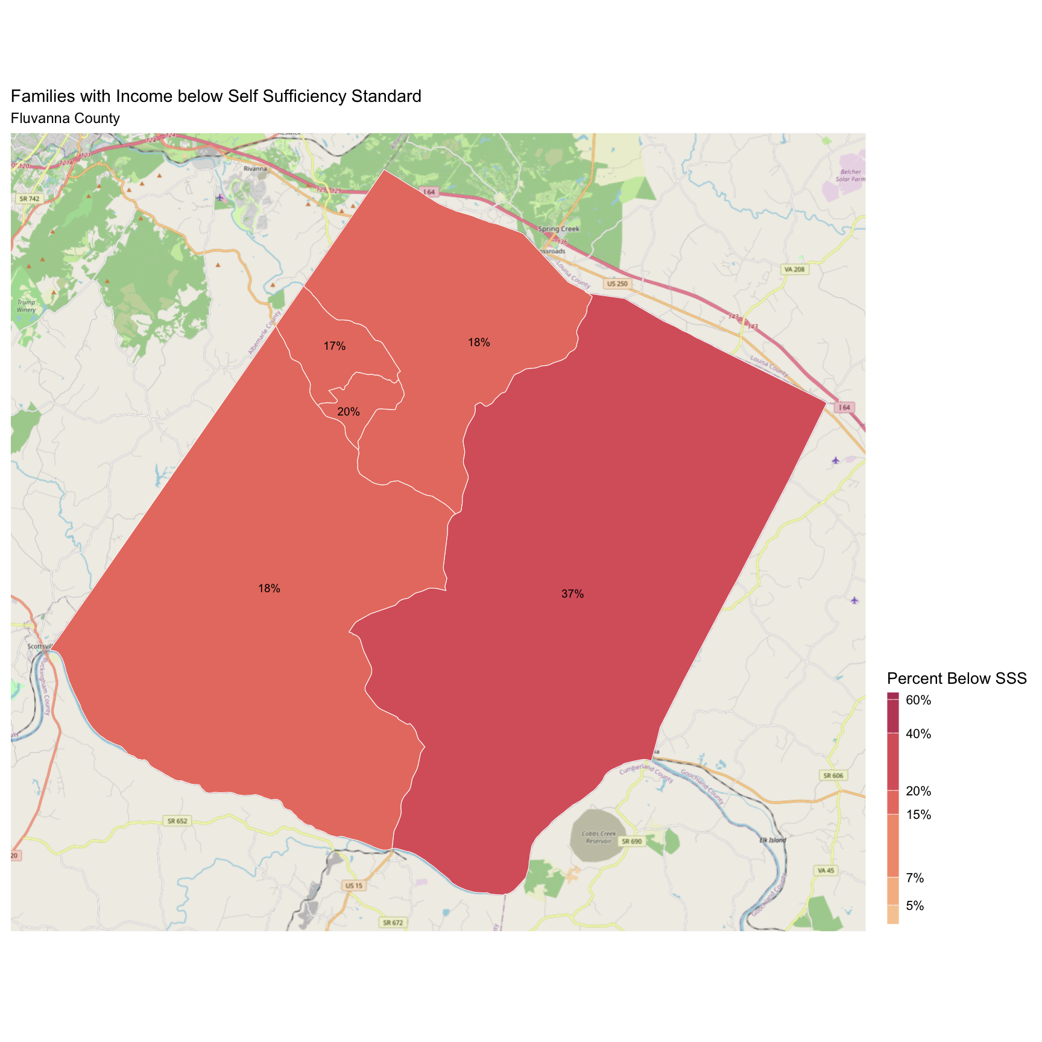

## Greene County

There are 5,753 families living in Greene County. Of these families, 1,312 (23%) do not earn enough to provide for their family’s basic needs.

Greene County at a glance:

The Self-Sufficiency Standard for an average family in Greene County is an annual income of $55,744.55. This is the income working families need to meet their basic necessities. These include: housing, child care, food, transportation, health care, miscellaneous expenses (clothing, telephone, household items), and taxes (minus federal and state tax credits).

Approximately 1,312 families, or 23% of families, in Greene County earn below the Self-Sufficiency Standard.

The percent of Black families earning below the Self-Sufficiency Standard is 64%. This is 46% higher than the percent of white families earning below the Self-Sufficiency Standard (18%).

The median family income for Greene County is $91,135. The tract with the lowest median family income is Stanardsville at $71,900. The tract with the highest median family income is Midway at $117,700.

The tract with the highest percent of families with income below the Self-Sufficiency Standard is Stanardsville with 37% of families. The tract with the lowest percent of families earning below the Self-Sufficiency Standard is Midway with 15% of families. That is a difference of 22%.

Table 1: Average Expenses and Self-Sufficiency Wages for Families in Greene County

|  | Monthly | Annual |
| --- | --- | --- |
| Housing Costs | $1,150.43 | $13,805.16 |
| Child Care Costs | $724.94 | $8,699.28 |
| Food Costs | $724.08 | $8,688.96 |
| Transportation Costs | $413.34 | $4,960.08 |
| Health Care Costs | $723.81 | $8,685.72 |
| Miscellaneous Costs | $373.66 | $4,483.92 |
| Taxes | $875.65 | $10,507.80 |
| Earned Income Tax Credit | -$4.81 | -$57.72 |
| Child Care Tax Credit | -$69.06 | -$828.72 |
| Child Tax Credit | -$266.67 | -$3,200.04 |
| **Self Sufficiency Wage** | **$4,645.38** | **$55,744.55** |
| Data Source: The Self-Sufficiency Standard for Virginia, 2021; The Center for Women’s Welfare, University of Washington | | |

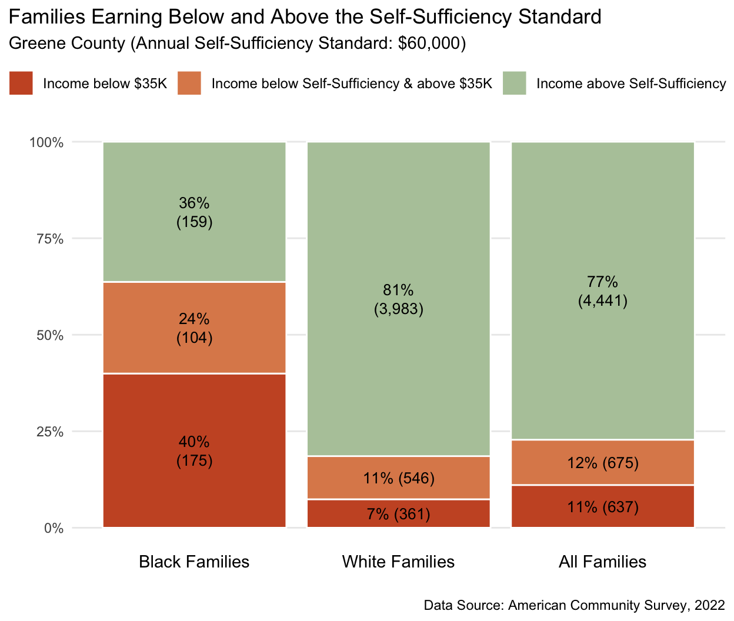

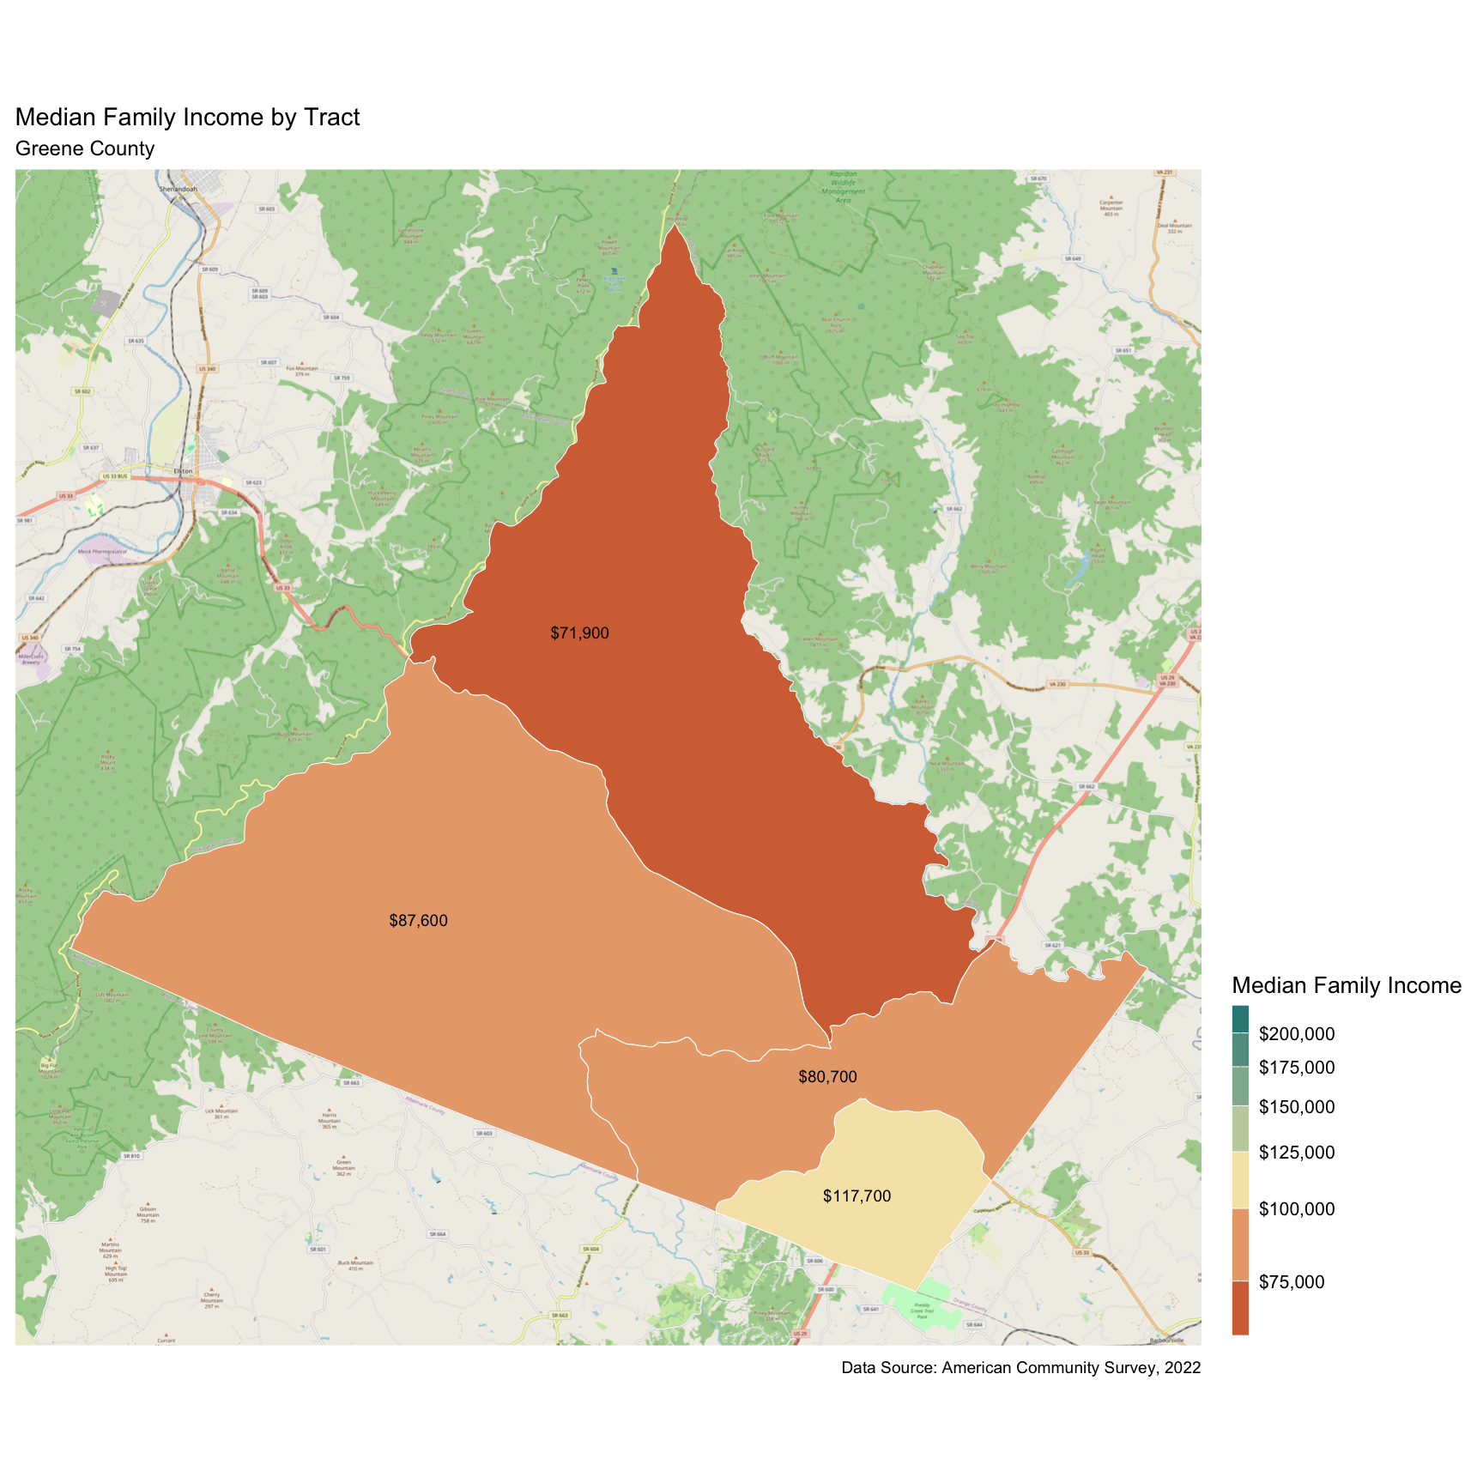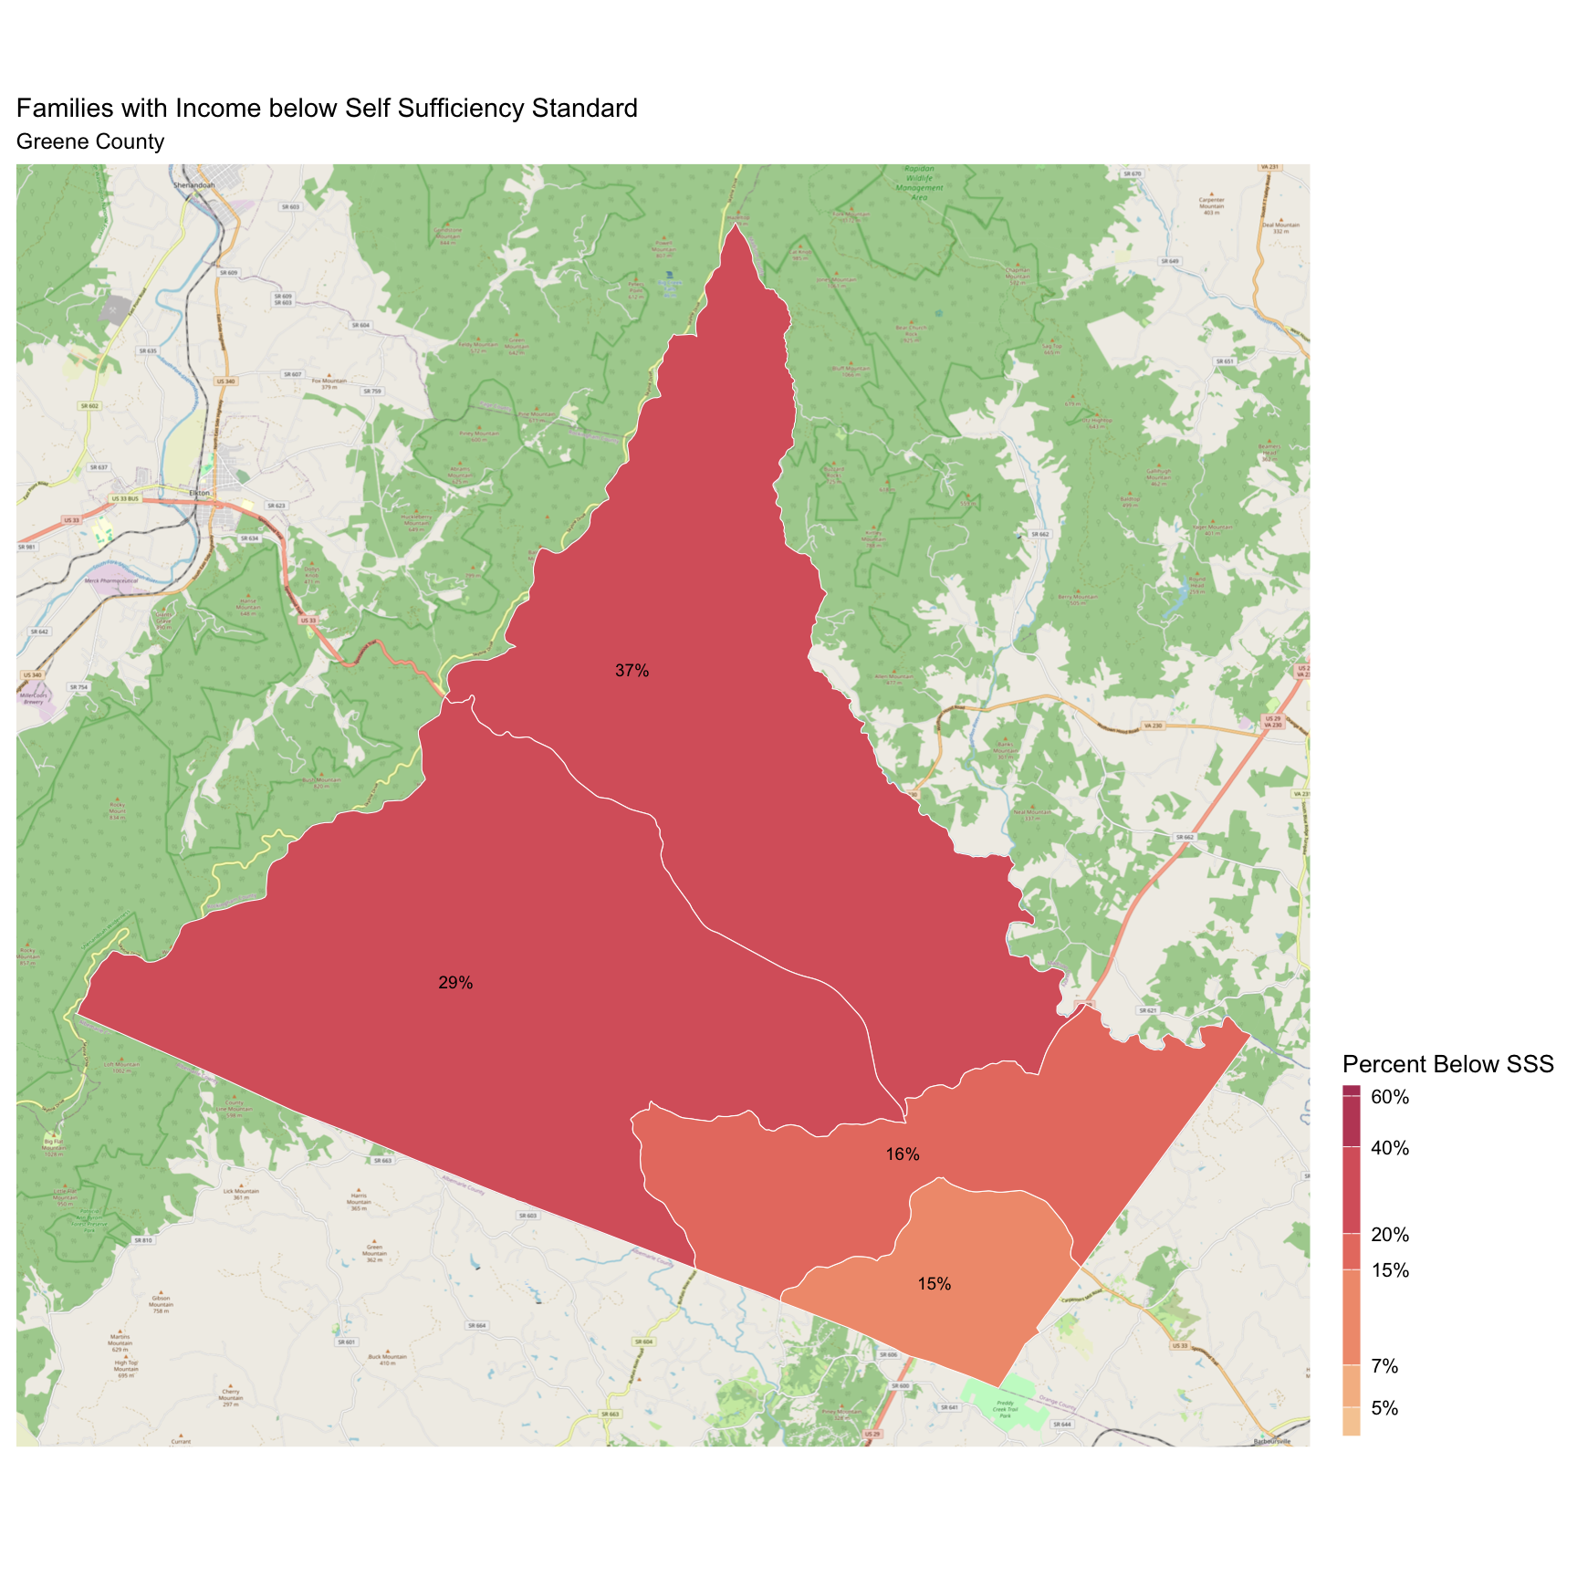

## Louisa County

There are 10,554 families living in Louisa County. Of these families, 2,410 (23%) do not earn enough to provide for their family’s basic needs.

Louisa County at a glance:

The Self-Sufficiency Standard for an average family in Louisa County is an annual income of $49,157.87. This is the income working families need to meet their basic necessities. These include: housing, child care, food, transportation, health care, miscellaneous expenses (clothing, telephone, household items), and taxes (minus federal and state tax credits).

Approximately 2,410 families, or 23% of families, in Louisa County earn below the Self-Sufficiency Standard.

The percent of Black families earning below the Self-Sufficiency Standard is 46%. This is 27% higher than the percent of white families earning below the Self-Sufficiency Standard (19%).

The median family income for Louisa County is $93,231. The tract with the lowest median family income is Ferncliff-Shannon Hill (Yanceyville) at $70,200. The tract with the highest median family income is Bumpus-Mountain Road District-Buckner at $126,700.

The tract with the highest percent of families with income below the Self-Sufficiency Standard is Cuckoo District with 32% of families. The tract with the lowest percent of families earning below the Self-Sufficiency Standard is Zion Crossroads with 12% of families. That is a difference of 20%.

Table 1: Average Expenses and Self-Sufficiency Wages for Families in Louisa County

|  | Monthly | Annual |
| --- | --- | --- |
| Housing Costs | $903.53 | $10,842.36 |
| Child Care Costs | $724.94 | $8,699.28 |
| Food Costs | $681.86 | $8,182.32 |
| Transportation Costs | $416.34 | $4,996.08 |
| Health Care Costs | $670.22 | $8,042.64 |
| Miscellaneous Costs | $339.69 | $4,076.28 |
| Taxes | $729.66 | $8,755.92 |
| Earned Income Tax Credit | -$33.63 | -$403.56 |
| Child Care Tax Credit | -$69.52 | -$834.24 |
| Child Tax Credit | -$266.61 | -$3,199.32 |
| **Self Sufficiency Wage** | **$4,096.49** | **$49,157.87** |
| Data Source: The Self-Sufficiency Standard for Virginia, 2021; The Center for Women’s Welfare, University of Washington | | |

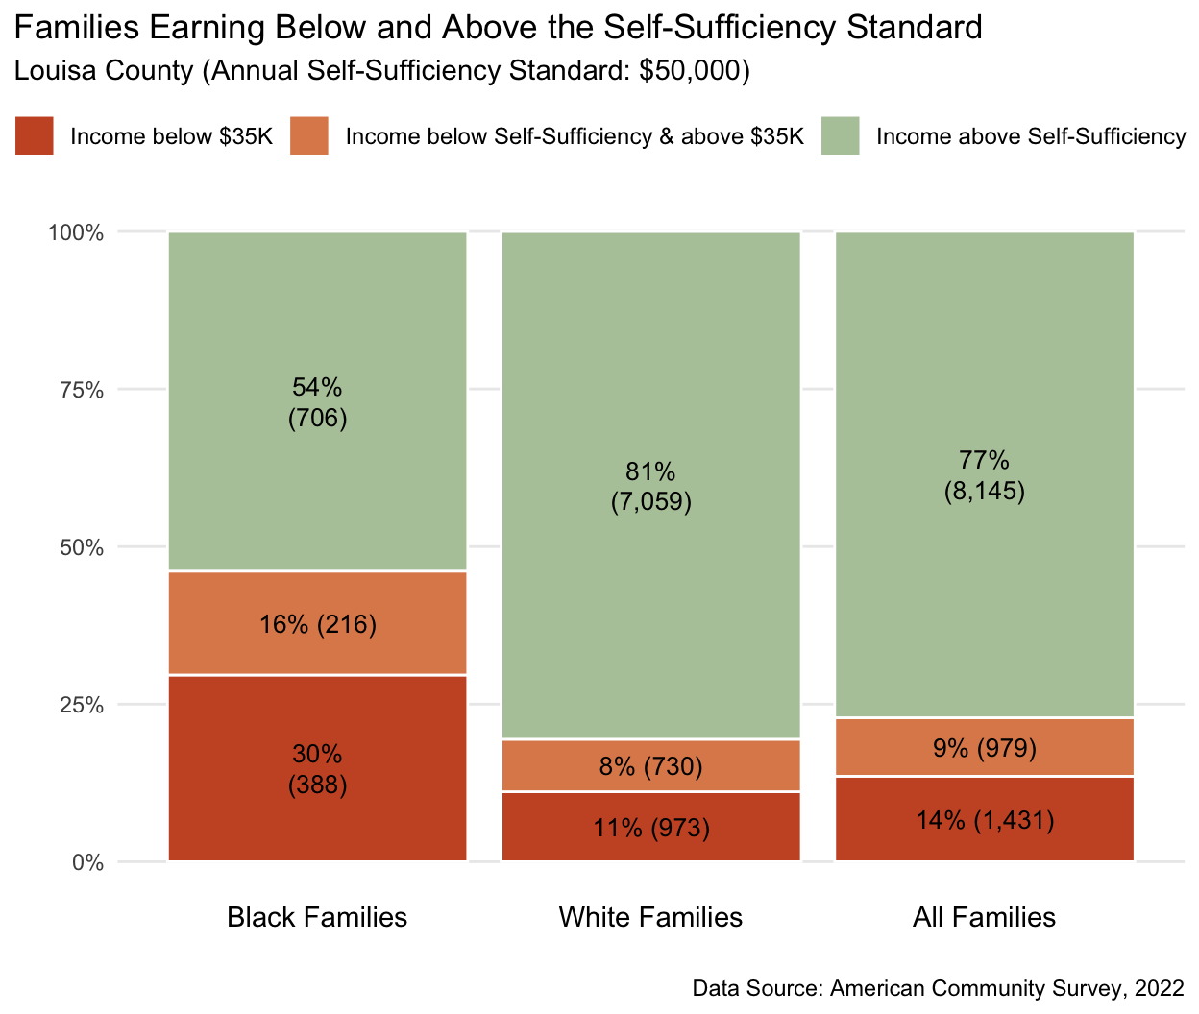

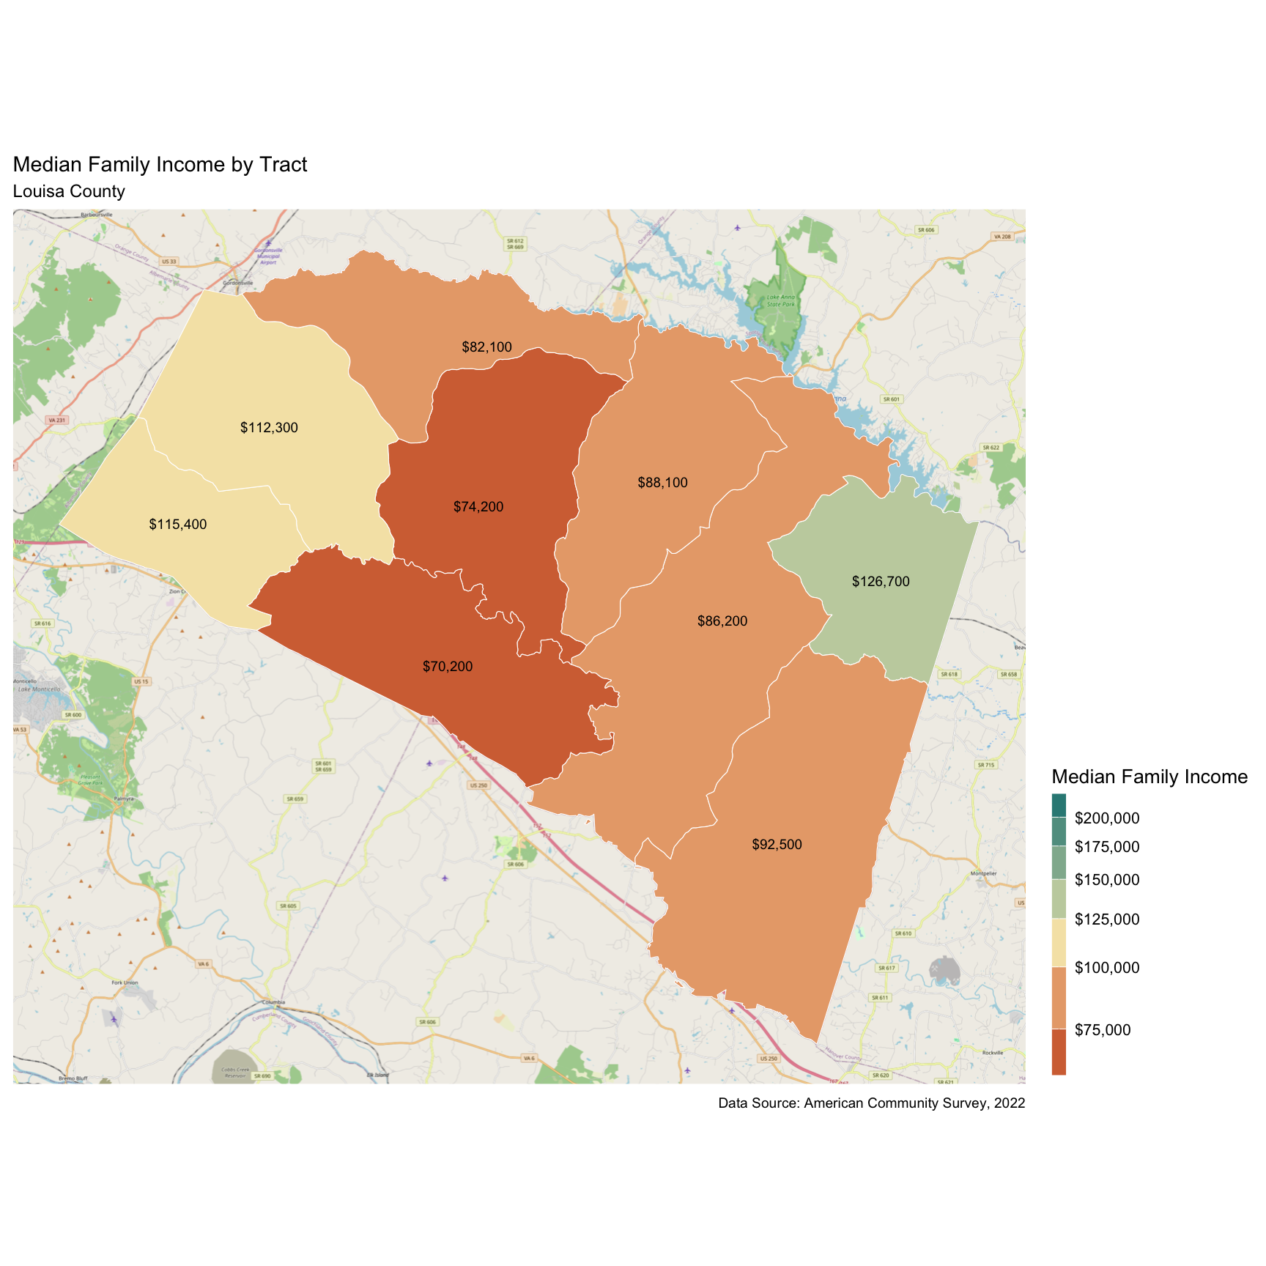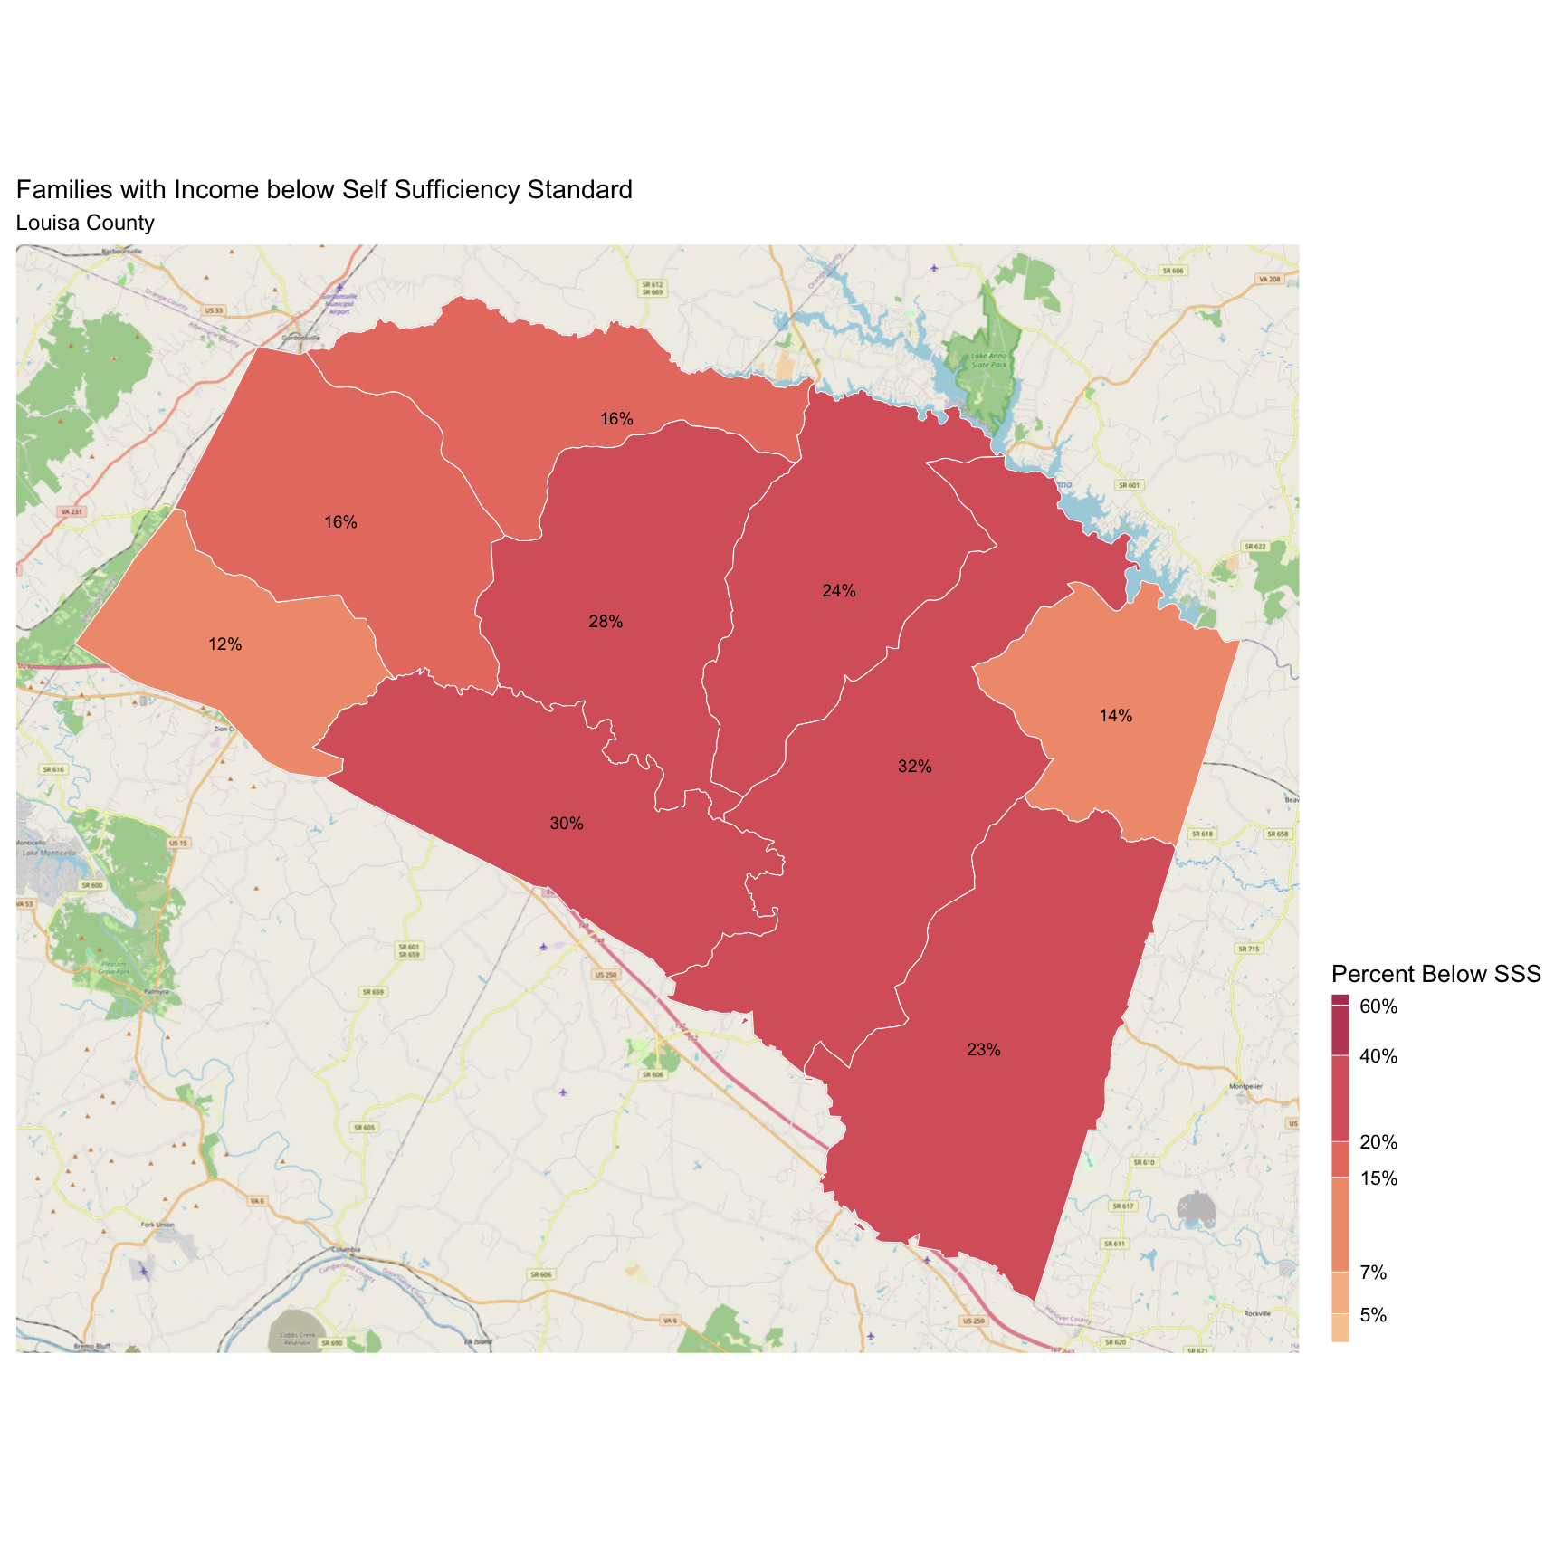

## Nelson County

There are 3,915 families living in Nelson County. Of these families, 1,278 (33%) do not earn enough to provide for their family’s basic needs.

Nelson County at a glance:

The Self-Sufficiency Standard for an average family in Nelson County is an annual income of $54,249.45. This is the income working families need to meet their basic necessities. These include: housing, child care, food, transportation, health care, miscellaneous expenses (clothing, telephone, household items), and taxes (minus federal and state tax credits).

Approximately 1,278 families, or 33% of families, in Nelson County earn below the Self-Sufficiency Standard.

The percent of Black families earning below the Self-Sufficiency Standard is 33%. This is 1% higher than the percent of white families earning below the Self-Sufficiency Standard (32%).

The median family income for Nelson County is $84,974. The tract with the lowest median family income is Wintergreen-Wingina at $63,200. The tract with the highest median family income is Wintergreen-Rockfish Valley at $137,600.

The tract with the highest percent of families with income below the Self-Sufficiency Standard is Wintergreen-Wingina with 42% of families. The tract with the lowest percent of families earning below the Self-Sufficiency Standard is Wintergreen-Rockfish Valley with 19% of families. That is a difference of 23%.

Table 1: Average Expenses and Self-Sufficiency Wages for Families in Nelson County

|  | Monthly | Annual |
| --- | --- | --- |
| Housing Costs | $1,108.65 | $13,303.80 |
| Child Care Costs | $731.92 | $8,783.04 |
| Food Costs | $683.97 | $8,207.64 |
| Transportation Costs | $410.34 | $4,924.08 |
| Health Care Costs | $723.81 | $8,685.72 |
| Miscellaneous Costs | $365.87 | $4,390.44 |
| Taxes | $841.14 | $10,093.68 |
| Earned Income Tax Credit | -$8.94 | -$107.28 |
| Child Care Tax Credit | -$69.30 | -$831.60 |
| Child Tax Credit | -$266.67 | -$3,200.04 |
| **Self Sufficiency Wage** | **$4,520.79** | **$54,249.45** |
| Data Source: The Self-Sufficiency Standard for Virginia, 2021; The Center for Women’s Welfare, University of Washington | | |

